

**Assignment number 1**

**Name: Zainab Riaz**

**ID: F2023105129**

**Course: Computer networks**

**Section: Y1**

**Instructor: Muhammad Ahmad Nawaz**

**Topic: Implementation of LAN Topologies Using packet tracer**

### Task-1:

**1. Bus Topology:**

* In a **Bus Topology**, all devices are connected to a single central cable (bus).
* A single collision domain exists, meaning all devices share bandwidth.
* If the bus cable fails, the entire network stops functioning.

**Diagram:**

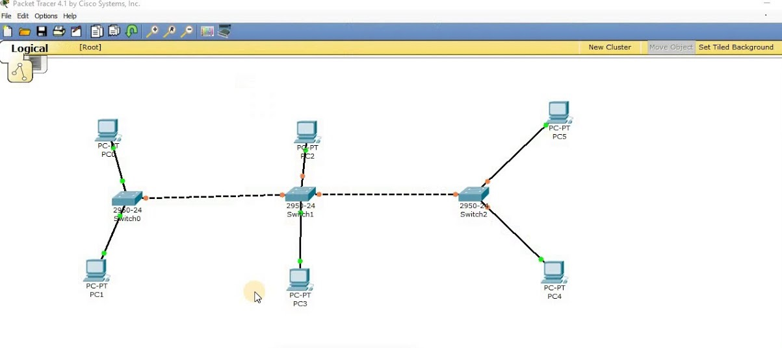

**2. Star Topology:**

* In a **Star Topology**, all devices are connected to a central switch.
* Easy to troubleshoot and expand.
* If the central switch fails, the network goes down.

**Diagram:**

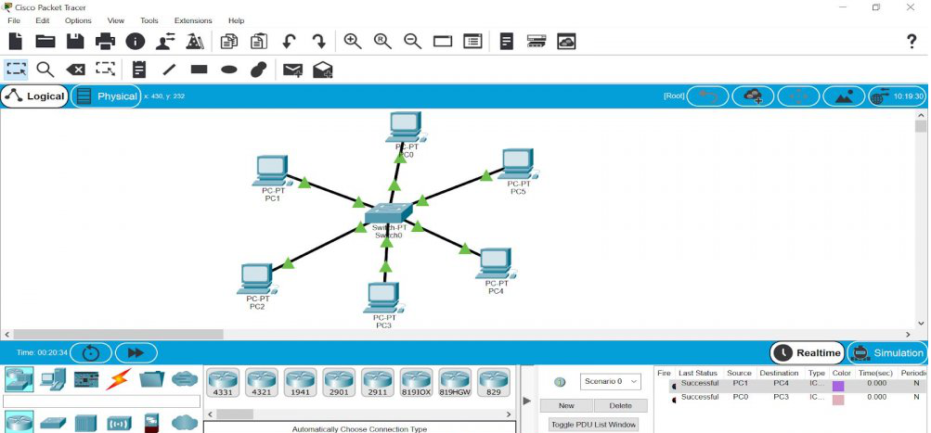

**3. Ring Topology:**

* Devices are connected in a closed loop.
* Data travels in one or both directions.
* Failure of a single device may disrupt communication unless dual-ring topology is used.

**Diagram:**

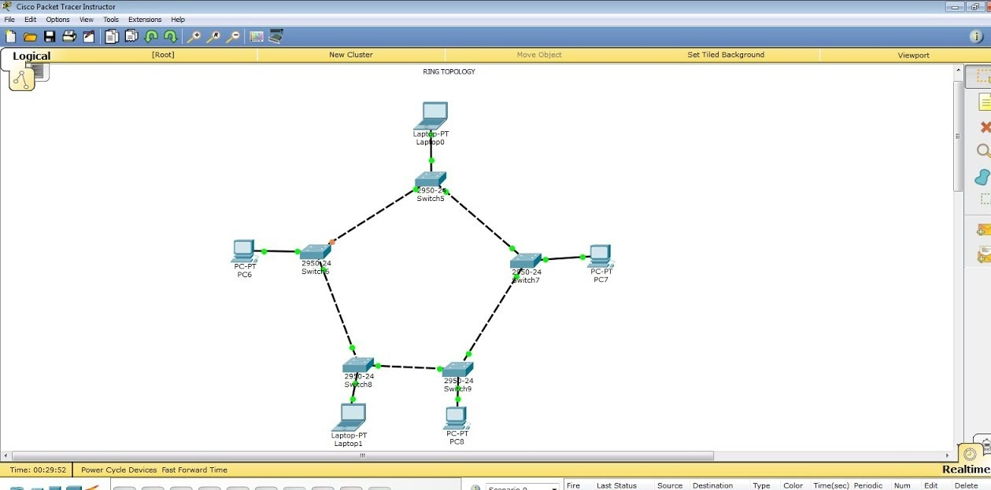

**4. Mesh Topology:**

* Devices are interconnected.
* Provides redundancy and reliability.
* Can be **Full Mesh** (all devices connected to each other) or **Partial Mesh** (some devices are connected).

**Diagram:**

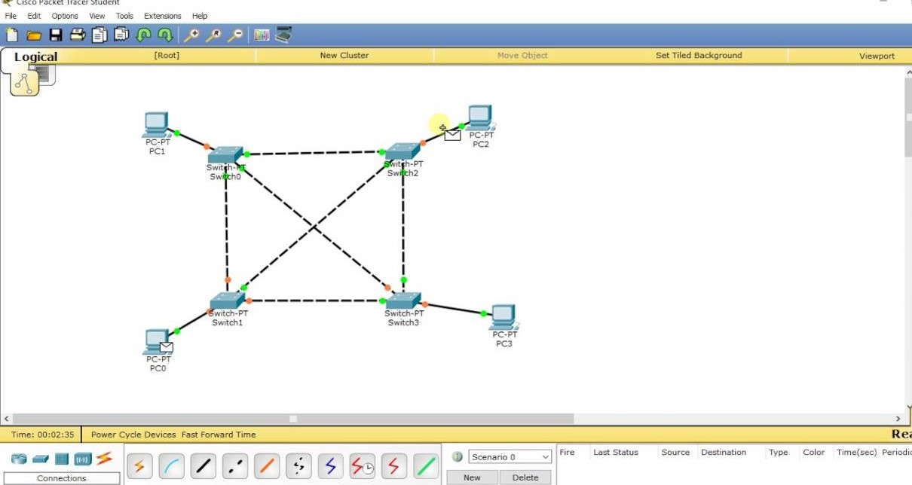

**5. Combined Network Topology:**

* All four topologies are interconnected using routers and switches.
* Each topology operates within a subnet for better management.
* Ensures diverse network communication models.

**Diagram:**

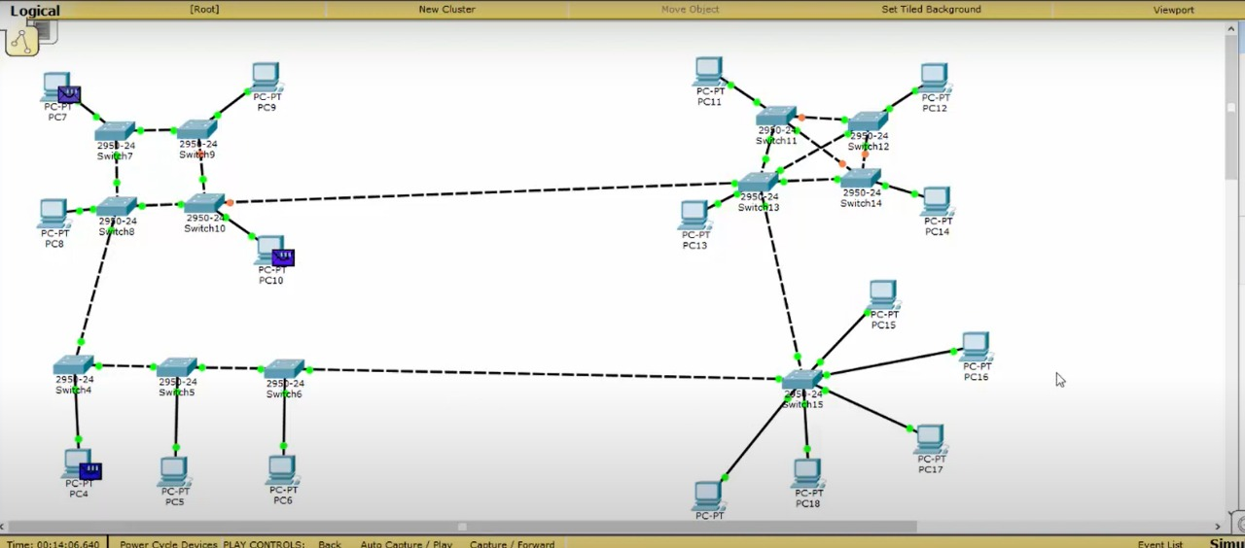

**Difference between Topologies**

Bus, Star, Ring, and Mesh topologies differ in their structure, performance, reliability, and best-use scenarios.

**Bus topology** connects all devices through a single central cable, making it cost-effective and easy to install. However, if the main cable fails, the entire network is disrupted, and performance decreases as more devices are added.

**Star topology**, on the other hand, connects each device to a central switch or hub, allowing for easy troubleshooting and expansion. However, if the central device fails, the entire network is affected.

**Ring topology** connects devices in a closed loop, where data travels in one or both directions. This setup minimizes data collisions and ensures efficient communication, but a single point of failure can bring down the entire network unless a dual-ring configuration is used.

Lastly, **Mesh topology** provides the highest reliability by connecting devices to multiple other devices, ensuring redundancy and preventing network failures. However, it is expensive and complex due to the large number of connections required. Each topology has its advantages and disadvantages, making them suitable for different applications, such as office networks, industrial environments, and critical systems that require high reliability.

**Task- 2:**

Design a topology using 4 PC and a Switch/Hub with following IP address:

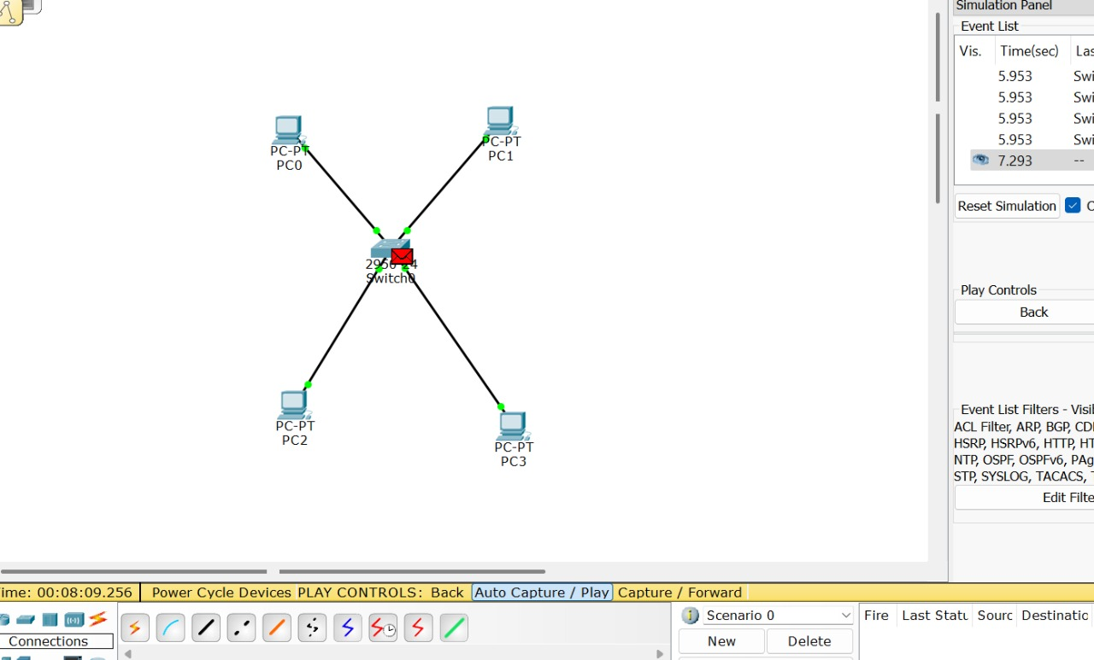

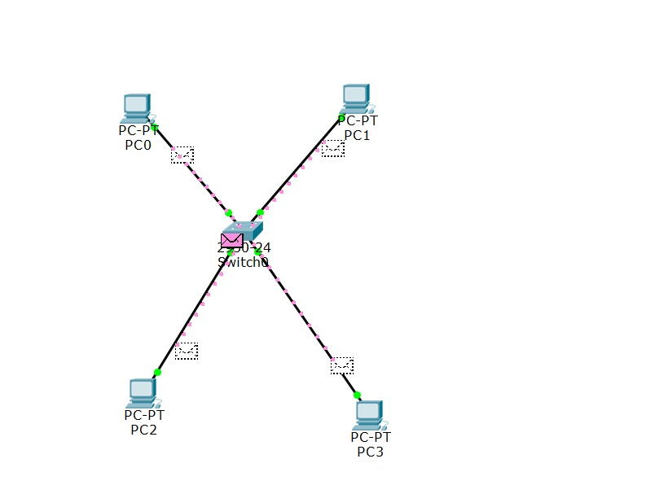

**THE END**